1956 Chevrolet Corvette Buyer's Guide
This highly desirable sports car ushered in ’Vette version 2.0
By Mike McNessor from May 2020 issue of Hemmings Motor News
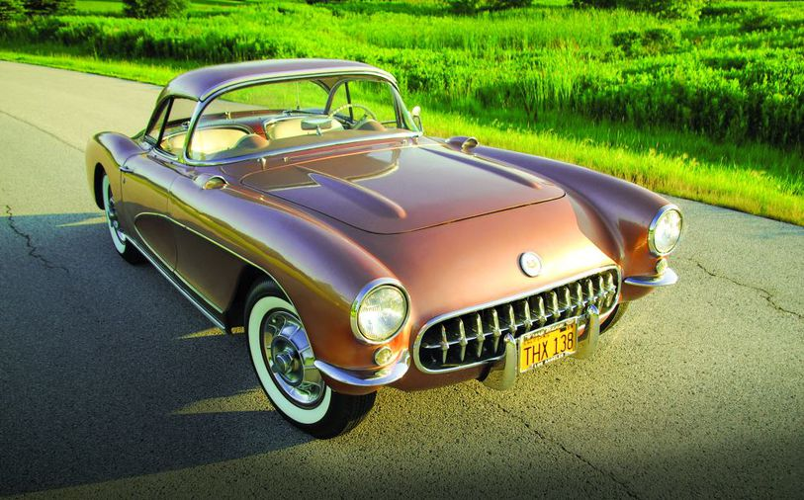

The 2020 Stingray upended more than 60 years of Corvette tradition and riled up a few traditionalists in the process. But that was exactly the point. Chevrolet engineers said that the switch to mid-engine was necessary to keep the car's performance on par with the Nürburgring set and its image relevant with a younger demographic.

Those born after the 1970s might think of the Corvette as evolving in a straight line from the 1950s to the 21st century. But gray beards know this isn't the first time that Chevrolet's two-seater needed an overhaul to keep it relevant. The redo that the original Corvette received in time for the '56 model year might seem less drastic than placing the engine behind the driver, but it was no less game changing.

The 1953-'55 Corvette seems quaint today, but its ride was rocky enough that the future of America's sports car was questionable. In the car's debut model year, 300 were hand-built in a temporary facility in Flint, Michigan. All were white with red interiors, had black canvas tops, and were powered by 150-hp 235-cu.in. six cylinders coupled to Powerglide transmissions. The price was high at $3,498—slightly more than the base price of a Jaguar XK120. What wasn't high was the quality of the car's fit and finish. Ditto for the car's performance and its weatherproofing. For 1954, new exterior colors and a beige soft-top were added to the offerings, plus a little more horsepower was on tap. Chevrolet dropped the price to $2,774, but it made the Powerglide transmission—the only transmission available—a $178.35 "option." The Corvette was on the ropes, as it wasn't flying out of showrooms, and might've been axed if it weren't for the introduction of the 1955 Thunderbird.

Ford's new two-seater made Chevrolet reconsider the Corvette's future and, for '55, the Bowtie-brand's new sports car rolled out with a 265-cu.in. V-8 and 12-volt electricals. Eventually, a three-speed manual would also be added. Sales were still dismal, and production slumped to fewer than 700 cars.

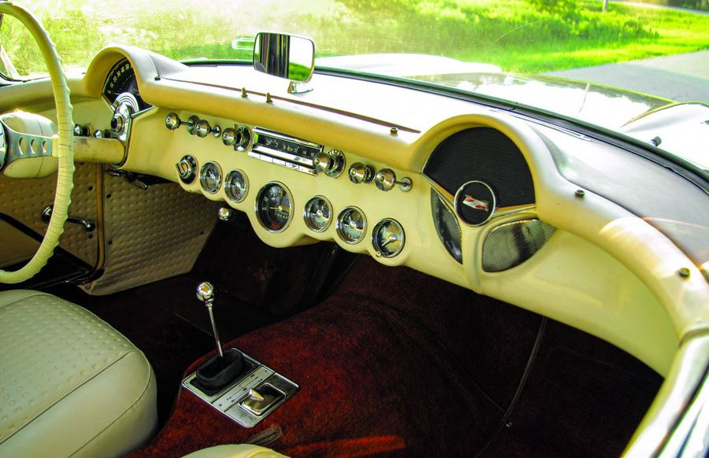
For '56, a three-speed manual and the Powerglide automatic were the only gearboxes available. This car rolled off the assembly line with a 'glide, but a previous owner had a Chevrolet dealer upgrade it to a T-10 four-speed.

The Corvette was rebooted for 1956 with an all-new look, as well as a number of improvements to make it more practical. The six-cylinder engine was dropped completely, and 265 V-8s with heady stuff like dual four-barrels and mechanical cams were on the option sheet. The '56 put the Corvette on the track to success and is today a popular collectible thanks to its good looks and relatively low (3,467) production. Recently, we spoke with John St Peter, the National Corvette Restorers Society's team leader for 1956-'57 Corvettes, about what to look for when shopping for a '56. Despite a trend toward declining interest in American cars of the 1950s, John is bullish about the 1956 'Vette.

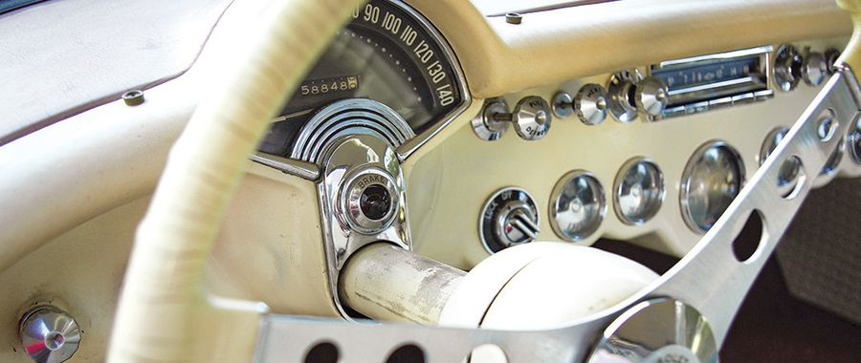
"They're becoming popular if you can find them," he said. "It's the body style: Years ago, it was in less demand (than the '57), because of the lower cubic-inch and lower horsepower engines, but I think buyers are starting to recognize the '56. Cars that are nicely restored are bringing pretty good money, because there aren't that many '57s available. If somebody has paid off their kid's college and is now looking for a car, they're finding that the '56, pricewise, is one of the best values out there."

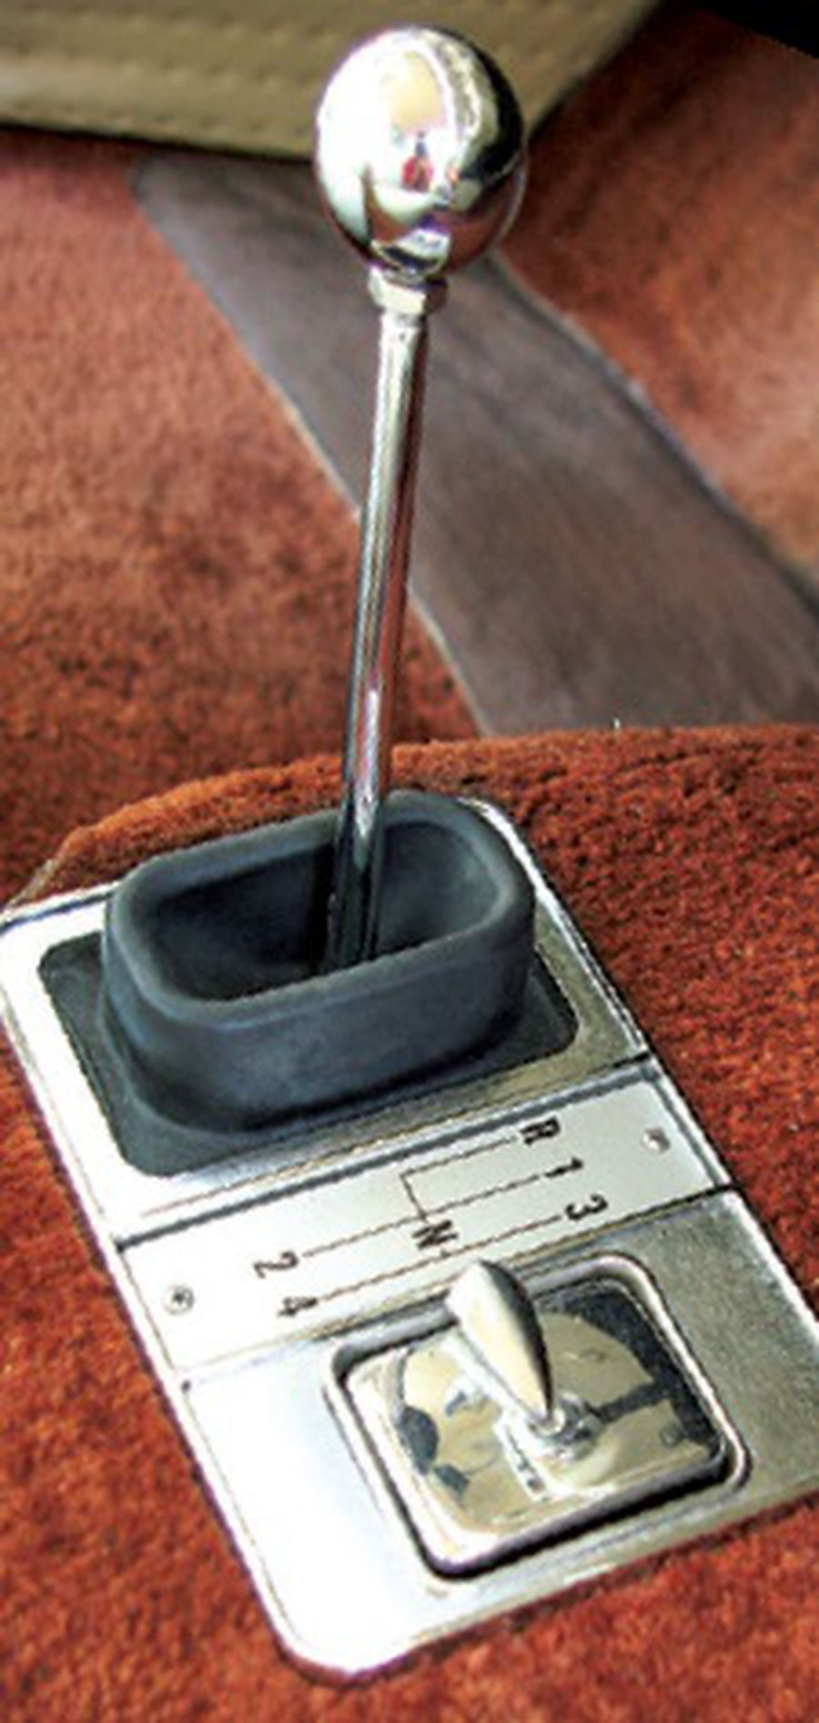
Body and Interior The Corvette's body was restyled for '56 and still constructed of fiberglass panels stitched together with bonding strips and adhesive. The smooth sides of the previous design were replaced with coves that paved the way for trendy two-tone paint schemes, while the stubby rocket-inspired tailfins of the 1953-'55 cars were shaved off in favor of a rounded posterior reminiscent of the Mercedes-Benz 300 SL coupe. The front fenders and hood also seemed to draw inspiration from the exotic Mercedes sports car and lent the Corvette some European flair. In addition to a styling upgrade, the '56's body included functional improvements like roll-up windows (or optional power windows) and exterior door handles. A soft-top was standard and many came with optional power assist. There was also a new removable hardtop that nicely complemented the car's body lines. An interesting detail that John pointed out as a way of spotting early production '56 Corvettes (first 200 cars) is that they had body-color headlamp rings. Also, cars with hardtops had a painted trim band at the forward edge that was later replaced by a bright piece.
Today, rust obviously isn't an issue with the body panels and, with minimal steel support underneath, the birdcage rust often found in mid-year Corvettes isn't something to worry about, but accident repair is pretty common.

"Many of these cars have been hit and it doesn't take much to crack the fiberglass," John said. "If you want to know if it's been fixed the right way, you have to look for the bonding strips and know where they are. For instance, on the fender well there should be a lip if you feel under the wheelwell—it'd be a ½- or ¾-inch strip—if there's been some damage, that can disappear. Look inside the trunk and in the corners in the wells where the lights go. In the old days, they didn't fix these cars to try and hide the repair, they just fixed them and painted them."
The '56 Corvette's interior was made racier than the previous edition with narrower bucket seats covered in a vinyl waffle pattern upholstery and smooth bolsters. Both seats were manually adjustable, and a storage compartment was added between the seatbacks. The instrument panel was carried over from the previous car, but the windshield wiper control was moved to the right of the headlamp switch and a T-handle replaced the hood-release knob. The steering wheel was a new three-spoke design with a center horn button embossed with the Corvette crossed flags. The floor shift was new, too, and sportier with a white plastic or chrome knob, and a rectangular bezel that incorporated an ashtray.

Reproduction parts, as well as restoration services, for Corvette interior goods are available, and it's possible to get very close to like-new condition.
"Everything isn't 100-percent copacetic, because some of the replacement upholstery is made using sheet goods for the waffle material, while at the plant they had waffle machines to make the pattern," John said. "It's not a big deal for the average owner, but it's important to understand what you're buying. I wouldn't ever not buy a car because of a replacement interior, but if that was one of 20 issues, it might factor into what I'd pay."

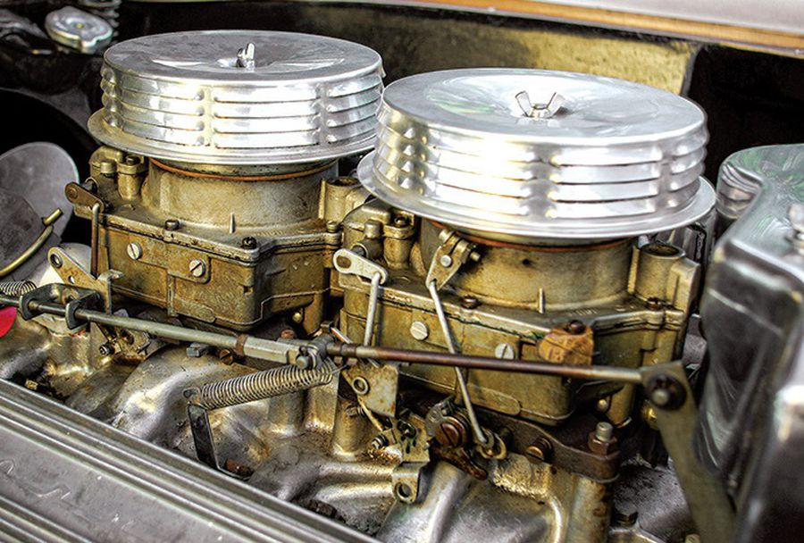
The vast majority of 1956-issue 265 V-8s in Corvettes were topped with dual fours. There were running changes made during the model year, including redesigning the exhaust manifolds. This engine has the later design.

Engine The 265 V-8 was standard issue in 1956 rather than an option, as it had been in '55. More horsepower was on tap, too, at 210 for the single four-barrel version versus 195 the prior year. Most Corvettes built in '56 boasted dual four-barrels, however, and there were two versions of that engine available: 225 horsepower with a solid-lifter camshaft and 240 hp with a special high-lift Duntov (mechanical) cam. The latter is the rarest of the breed with just 111 built, compared to 3,080 of the standard dual-four barrel engine.

There were some differences among early and later 1956 Corvettes, and that's particularly true under the hoods. For instance, the early '56 Corvettes (serial numbers 1,000-1,700) used exhaust manifolds that are virtually unobtainable today.
"The first 700 cars used a two-bolt exhaust manifold (the headpipe attached with two bolts rather than three) and it's a single exhaust header that fits both sides," John said. "Those just don't exist. I haven't been able to find one for years. There's been talk of reproducing them, but the cost would be extremely high." These early engines also used an oil pan with a triangular-shaped receiver riveted to the side that accommodated a dipstick. Later engines had the tube inserted through the block.
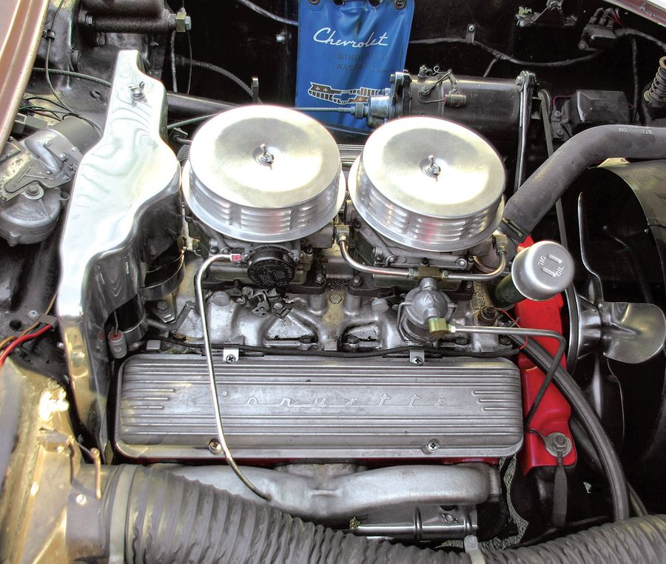

Determining whether or not a '56 Corvette's engine is original to the car can take some sleuthing, because there is nothing stamped or cast on the engine that correlates to the car's VIN or serial number. A block with a casting date that precedes the car's build date, according to the serial number, is one indicator. A stamping on the engine pad will have the engine's serial number (with no correlation to the car's serial number), as well as one of five suffix codes: "FK" for the base four-barrel engine with a Powerglide; "GV" for the base engine and three-speed; "FG" and "GR" for the dual four-barrel engine with the Powerglide (FG) or three-speed manual (GR); and "GU" for the dual-four-barrel with a high-lift camshaft. Corvette experts will inspect the machining patterns on the block, known as broach marks, to determine if the pad has been altered in any way. While blocks can be stamped with a new suffix code to correspond to a Corvette, authentic broach marks are difficult to replicate.

"Pickup trucks and old sedans had single-digit horsepower designations (suffix codes) and they're the same first digit as the Corvettes that had two-digit indicators. If you can find a truck engine—it's the same casting number—you have to find the correct matching font stamp to put in the second horsepower indicator. Even for our judging, that's fine. But if it's got phony broach marks, made with a grinder or sander, that isn't okay for judging," John said. "If somebody is just buying the car to drive it around and doesn't care about judging, this isn't critical, but it can affect the value of the car: as in, what they're going to pay for it and what they're going to sell it for when they decide to move it along."
Locating correctly coded accessories and components—carburetors, distributors, exhaust manifolds, starter, generator, etc.— can be a challenge, but keeping a 265 in working order isn't.
"Rebuilding these engines is pretty straightforward," John said. "A 265 is not difficult to work on."

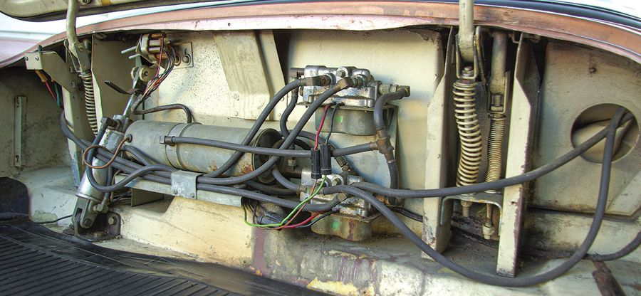
A power-assisted soft-top was offered as an option for the first time in 1956, as was a removable hardtop. This drastically improved the car's four-season capabilities. Roll-up windows and outside door handles were new, too.

Transmission and Axle Corvettes came standard with a close-ratio synchromesh three-speed transmission. It differed externally from the passenger-car three-speed in that it had mounting pads for the floor shifter on the tailshaft housing, as well as a pad underneath for the rear transmission support. The clutch was a 10.5-inch Borg-Beck type. Chevrolet's two-speed Powerglide was also on the menu for '56 Corvettes. Both transmissions are simple and durable, though perhaps not terribly exciting.
"The three-speeds are simple and there's a number of guys who still sell and rebuild them," John said. "The best car—as far as not being beat up—is one with a single four-barrel engine and an automatic transmission."

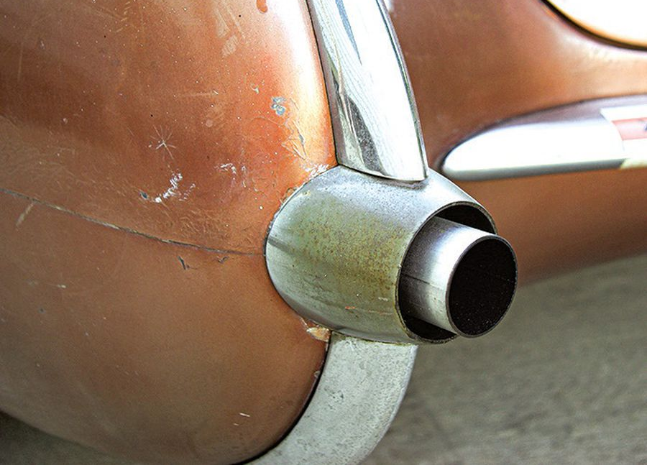
The solid axle rear used in the '56 was equipped with larger differential bearings for increased durability. A 3.55:1 ratio was offered with both transmissions and a 3.27:1 could be paired with a manual. Parts are widely available for these rear axles, but not everything interchanges among 1956- '62 units.
"You rarely find damage to the housings and the gears are standard," John said. "Plus, there are plenty of aftermarket replacement parts."
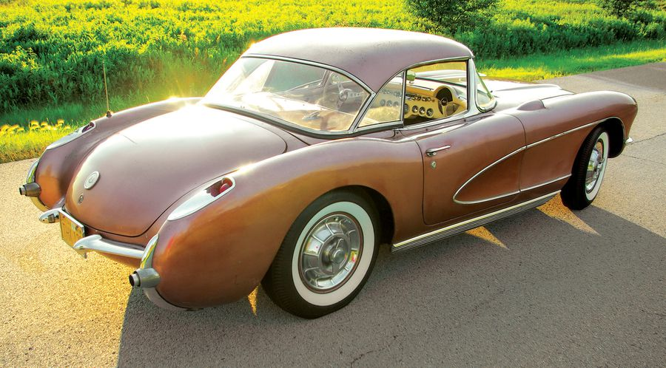

Chassis and Brakes The 1956 frame was unchanged from '55, though the suspension geometry was tweaked, and the brake shoes were upgraded. The fuel tank, too, was reconfigured—to make room for a larger folding top compartment—and held slightly less fuel.
The frames underpinning these Corvettes were rugged, but not impervious to rust.
"Frame rot can be an issue especially with Northern cars," John said. "The kickup areas in the back can be susceptible. When these cars were new, they weren't always garage-kept and owners drove them every day, so Southern or Western cars are usually in better shape."
A rusted frame isn't a death sentence for a Corvette, of course, as long as the rails are competently rebuilt.
"A good welding shop with jigs and trained guys can repair damage," John said. "There are plenty of guys out there who can do the work—you just have to find someone with a reputation and experience."
Replacement chassis components are readily available to keep your Corvette on the road, though tracking down factory-correct components is more of a challenge.
"There is plenty available from the aftermarket and available at the local auto parts store," John said. "It might not pass judging, but if you're driving the car you're going to get just as many oooh ahhhs when you pull into the gas station. These parts look _ ne, the car will work _ ne, and 99.5 percent of the people don't know the difference."
PARTS PRICES
Axle rebound strap $93
Brake line kit $150
Brake hose set (OE style) $43
Carpet set $363
Differential rebuild kit $150
Door window regulator repair kit $25
Dual master cylinder upgrade $298
Flywheel bolt kit $12
Front brake hardware kit $30
Heater core gasket set $23
Ignition and door lock set with keys $104
Ignition shield kit $707
Speedometer lens set $55
Steering knuckle kingpin bushing kit $80
Water pump rebuild kit $80

WHAT TO PAY
Low $44,000
Average $73,000
High $108,000
*Add $3,500-$5,000 for both tops
*Add 15 percent for 225-hp V-8, 20 percent for 240 hp

