

Michigan
“Where it all began”

Michigan SACC Volume 2, Issue 1 Spring 2011

2011 Chapter Activities

March 13, 2011 MEMBERSHIP MEETING
Karl's Cabin
6005 Gotfredson Rd, Plymouth, MI
12:00 noon

Membership Meeting

Fellow MCSACC members,

Everyone is invited to a gathering of Michigan C1 enthusiasts to again attempt to unite with a common purpose and focus on enjoying one of Michigan creations – our C1s…
We will be gathering at Karl’s Cabin, 6005 Gotfredson Road, Plymouth, MI on March 13 at 1:00 pm.
Karl’s if located ½ mile north of M-14 and is open from noon to 9pn on Sundays.

The meeting agenda will include:

12:00 pm Outdoor meet and greet
12:30 pm Lunch
1:15 pm Call meeting to order
Chapter Status with National
Nomination of officers for 2011-2012
Election of officers
Treasurer’s Report /2011 Membership
Report on National Convention
Discussion of possible MCSACC events
Selection of events
Selecting event champion
The beginning of a beautiful friendship

Suggestions on page 2 are thought generators, bring yours!!

We are looking forward to seeing all of you there.
If you plan on attending
Please advise Bill Huffman: email:swh73@comcast.net

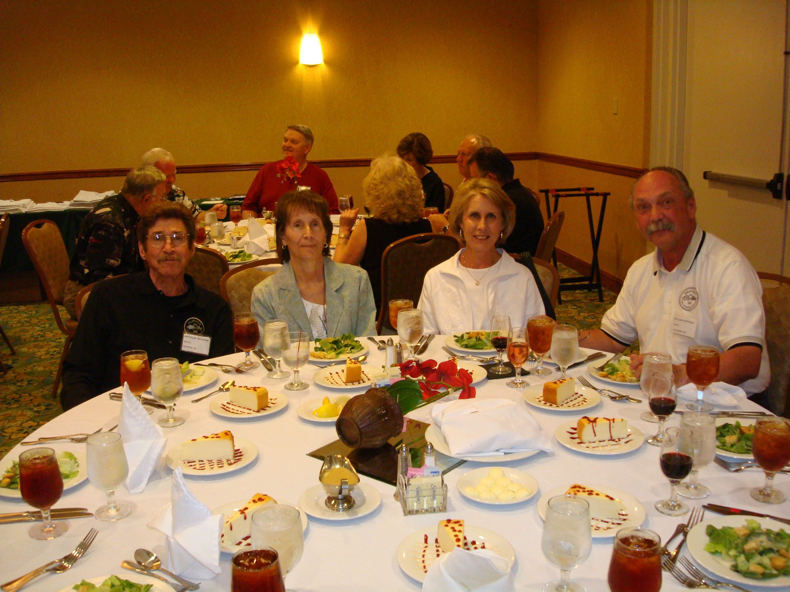
Art & Carol Wyman of Fenton and Bill & Stef Huffman of Jackson at SACC National Convention in Fla.

Inside this Issue

Page 2 Message to the Membership

Page 3 Technically Speaking

Page 4 Links
Page 5 Membership Form
Page 6 Organizational volunteers
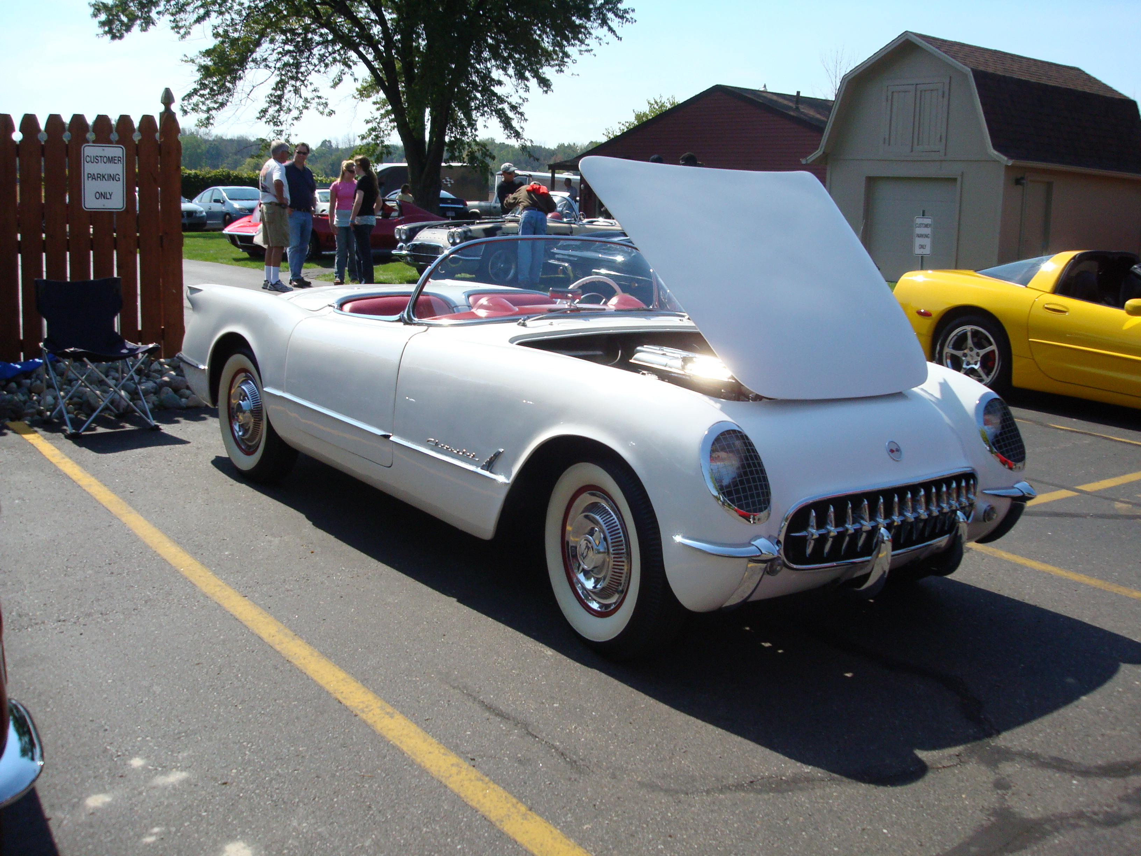
Tom Gamache's 1954

Michigan Chapter E-mail: druby@comcast.net
of the Solid Axle Corvette Club Website:
30120 Lincolnshire E., Bevelry Hills, MI 48025 Phone: 248-644-6879
Message to the membership:
We offer this list of possible MCSACC events for 2011. We need 3 or 4 to be a functioning organization. Come to Karl’s Cabin on March 13 and vote in your favorites.
These are not firm, no advance planning has been done, but are suggestions for thought and consideration of all members. See you on March 13 at Karl’s Cabin.

- Spring road tour in late May for a late breakfast/lunch as a Meet/Greet, somewhere along I- 69. Perhaps in Perry @ the junction of I-69 & M-52 ? Or as an alternate Cornwell's Turkeyville, 18935 15 1/2 Mile Rd, Marshall, Mi. Located 1 mile west of I-69, 1st exit north of I-94.

- "Corvette Crossroads at Mackinaw" is held every year the first weekend before Labor Day.
$25 entry fee, nice drive, great scenery and plenty of shopping for the ladies. Unfortunately, same weekend as Dream Cruise & Corvettes at Carlisle.

- August 14th, 9:00 am to 4:30 pm Corvette America will host a huge Corvette Show & Swap- meet with dozens of early cars whose owners are not SACC members but could be. This year the meet will be held at Pine Knob Golf course, Clarkston, Michigan. For those of us on the west side of the state it's a great show.

- Each year on Sunday in mid-May, the Battle Creek Corvette Club hosts a one day Corvette Car Show in Marshall, MI at the Calhoun County fairgrounds. $10 entry fee. Perhaps dinner @ Schulers. Can be chilly there.

- Gilmore Car Museum, 6865 Hickory Rd, Hickory Corners, Mi. could provide a rendezvous point for a possible weekend event. Open May thru Sept. $10 admission.

- Sunday, July 31, 2011 Concour’s d’elegance of America will be held at St. John’s, 44045 Five Mile Road, Plymouth, MI 10:00 am to 4:00 pm. (Formerly held at Meadow Brook Hall)

- August 20, 2011, Woodward DreamCruise, Woodward Avenue from Pontiac to Berkley

- North Oaks Corvette Club Corvette Fest benefits Leader Dogs for the Blind.
June 18 - 2369 Joslyn Court, Lake Orion, Mi. $25 Fee.

- Mid-July, the Onsted Kiwanis hosts a Car show at Michigan International Speedway infield. This year Corvettes will be allowed out on the track to run a few laps. $47 entry (including track time). Deadline is about 15 June.

- September 18, Paragon Corvette Reproductions in Swartz Creek, MI hosts a Fall Open House including beverages, lunch & T-shirt. Always a good time to pick spare parts at a reasonable price.

- A "Color Tour" in mid-October This year, using Frankenmuth as a base, a tour of the thumb coastline would be interesting. We could combine the Color Tour with the "Lighthouse Tour". Bavarian Inn hotel & Bavarian Inn restaurant are very good.

- National Cherry Festival in Traverse City July 2-9, 2011. This is not only was it a great event but there is a car show for those interested –July 1 at 6:00 pm, Cruise Night at Turtle Creek Casino, Williamsburg; July 3, 11:00 am to 4:00 pm Old Town Car Show. The drive up the peninsula to the lighthouse is spectacular.

- In addition, there are various non-car related festivals that might be fun for both spouses:

- Be prepared on March 13th to add to the option; Visit State Parks, Amish Country, Leelanau Wine Tour
Technically Speaking…

... a voice of experience By John Hutchins

This column is a reprint from our August 2008 newsletter and is intended to be a question and answer forum for Chapter members who are seeking assistance with particular restoration issues concerning the Solid Axle Cars. You are invited to submit questions via email kjhh41@hotmail.com Please put “SACC Tech question” in your subject line. I will attempt to address the questions promptly and if I do not have an answer I will try to seek the help of others. Issues thought to be of the greatest interest will be selected for publication here. I have a greater amount of information on the 53-57 cars than I do on the 58-62 years.

A 1955 owner asks: my 55 had been sitting for a very long time when I began the restoration. As I began taking things apart for a body off I noticed the smell of old gas. I found that when I had loosened the tank straps that I had also loosened the rust under them and the tank began to leak. I found a nice tank from a ’60 but discovered that it will not fit. What are my options?

The first option would be to find a 53-55 tank, #3706137, which is an 18 gallon gas tank identical to your original. The 1960 factory tank is a 16 gallon unit and very similar to the 56-62 reproduction tank currently available but will not fit 53-55’s. I have heard that there was a service tank, #3796030, that would work in all 53-62’s but it was discontinued in the early 1970’s and the chances of finding one are slim. The design of the 16 gallon tank was necessary to accommodate the power top mechanism .

The second option would be to repair your original tank. There are sealer kit available that may work on the home work bench but with limited success. I would advise leaving the repair to the professionals. You may find a radiator repair shop that can handle the job but the best answer that I am aware of is the “Gas Tank ReNu” process” which is advertised nationally. There are several shops located through Michigan. They have a web site, www.gastankrenu.com, which explains the process. After physical repair of the holes they apply an inner sealer and then a different sealer to the outer surface. This can create an issue with the ground path of the tank unit which will cause the dash gauge to read full all the time. Be sure to establish a good ground path.

A word to the wise would be to make sure that you use a “Water Remover” in your fuel when storing you car for any length of time, like over the winter or longer. Also, the use of a “Sta-Bil” product is useful if you prefer to store your car with near a full tank.

Newsletter publication dates – February, May, August, November

EDITOR COMMENTS – DAVE RUBY

We hope that the newsletter will provide you with useful information and that it will continue to grow. We expect the basic format of the newsletter to be flexible and to that end we have left open what we publish—essentially, if it is of interest to the Michigan SACC community, we will print it. Obviously, we won’t reprint copyrighted material without permission, but anything original should find its way into the pages.

Generally, I’ll run whatever you send in as you prepared it, however, I reserve the right to edit for “good taste” and, of course, I’ll correct obvious spelling or grammar errors. We will be keeping the length of Michigan to a reasonable length, so depending on the amount of information we have for publication; your input may have to wait for the next issue. But, rest assured it will find its way into the newsletter.

We plan to send the newsletter out in February, May, August, and November. Therefore, please send items for publication to me by the 10th of the preceding month.

In summary, this is your newsletter—I just cut and paste the pieces together. So if there is something you would like to see here, please let me know. E-mail: druby@comcast.net, phone: 248-644-6879, mail: 30120 Lincolnshire E., Beverly Hills, MI 48025

If you would rather receive an electronic copy, send me an e-mail at: druby@comcast.net

Links

Corvette Central | www.corvettecentral.com
Eckler’s Corvette Parts & Accessories | www.ecklers.com
Mid America Motorworks | www.motorworks.com
Mid Atlantic Chapter SACC (MACSACC) | www.masacc.org
National Corvette Museum (NCM) | www.corvettemuseum.com
National Corvette Restorers Society (NCRS) | www.mcrs/prg
Northwest Chapter SACC (NWSACC) | www.nwsacc.org
Paragon Reproductions | www.corvette-paragon.com
Solid Axle Corvette Club (SACC) | www.solidaxle.org
Central Great Rivers Chapter  America’s Corvette club | www.casscomm.com/~wcic/  www.americascorvetteclub.org/
Car Show Central www.carshowcentral.com/

National Cherry Festival www.cherryfestival.org/events/everything.php

Corvette Clocks by Roger www.corvetteclocks.com

Zip Products www.zip-corvette.com

Welcome to the Michigan Chapter
SOLID AXLE CORVETTE CLUB
Michigan SACC Chapter Membership Application for 2011

Michigan SACC Chapter Membership requires membership in the National SACC organization.
To make record keeping easier Michigan SACC collects both National and Chapter dues and submits National dues to the National office.
Annual Chapter dues are $15. and National SACC dues are $35. renewable every December.

Chapter dues include our quarterly Chapter Newsletter “Michigan”

National Membership includes the quarterly magazine “On Solid Ground”

If you are a new member the National SACC will send you a Natl. membership # separately.
See WWW.solidaxle.org/forms for national membership application form.

If you are an existing National member please insert your national membership #____________

Please make checks payable to: MISACC and mail to:

Kelvin Wilbon
MI SACC Treasurer
PO Box 978
Davison MI 48423-0978 Questions: (810)-653-2644 kwilbon244@charter.net

Applicant Name ______________________________________________________

Co-Applicant: ________________________________________________________

Address _____________________________________________________________

City _____________________________________State: _______Zip:___________

Home phone _________________________Work/Cell: ______________________

E-Mail _____________________________________ Fax: ____________________

Corvettes presently owned - please include the Serial # for all C-1’s

___________________ ___________________ ____________________ ___________________

I will enjoy participating in these club activities: Driving tours___ Get away weekends ___

Museum tours ___ Historic site/shop tours ___ Car Shows ___ Tech sessions ___ Race events___

Newsletter Contributions ___ Tour/Event Planning ___ Other______________________________

I would be interesting of chairing an event or gathering. Yes____ No____

Description of the event or gathering___________________________________________________

I am currently a member of the following Automotive clubs/organizations:

Michigan Chapter SACC

2011 Organizational Volunteers

President: Vacant

2008 Vice President:
Bill Huffman
2200 N Sandstone Road
Jackson, MI 49201
swh73@comcast.net

Secretary: John Hutchins
9417 N. Rich Rd.
Alma, MI 48801
kjhh41@hotmail.com

Treasurer: Kelvin Wilbon
P.O. Box 978
Davison, MI 48423-0978
kwilbon244@charter.net

Membership: Vacant

Editor: Sue & Dave Ruby
30120 Lincolnshire E.
Beverly Hills, MI 48025
248-644-6879
248-514-2677-Cell
druby@comcast.net

Tech Advisor:
John Hutchins

Event Organizer:
Rick Smith
170 Lake Forest Ct.
Niles, MI 49120
hummerrick@msn.com

Road Rules

The Michigan is the quarterly newsletter for the Michigan Chapter of the Solid Axle Corvette Club and is published four times yearly (Spring, Summer, Fall & Winter). A copy is sent to each member in good standing.

Membership in the Michigan Chapter is open only to members of the parent organization, the Solid Axle Corvette Club. The Solid Axle Corvette Club is a non-profit organization, serving members with an interest in 1953—1962 model year Corvettes. Ownership of a Solid Axle or any Corvette is not necessary to become a member of the organization.

The newsletter provides a forum for members to communicate with other members. As a result, the newsletter will often contain member opinions. Those opinions should not be construed as an endorsement by Michigan SACC or the parent organization, SACC.

Direct SACC Membership questions to:

Lucy Badenhoop, SACC
P.O. Box 2288
N. Highlands, CA 95660
e-mail: badenhoop@comcast.net

Direct Michigan membership inquiries and corrections to the address list should be directed to the Treasurer:

Kelvin Wilbon
P.O. Box 978, Davison, MI 48423-0978
(847) 891-5636;
e-mail; kwilbon244@charter.net

Please submit articles for publication to the editor. Generally, articles for publication should follow the broad theme of “Anything of interest to the Solid Axle Corvette community”. Suggested items for publication would include how-to articles, parts information, performance issues, scheduled events, restoration or repair information, and personal stories.

The Michigan editor can be reached at:

Dave Ruby, Editor
Michigan Chapter SACC
30120 Lincolnshire E.,
Beverly Hills, MI 48025
248-644-6879;
e-mail; druby@comcast.net

